Study the following words for spelling test.
Test is due on Wednesday 5/23/18
The picture | The meaning | The word
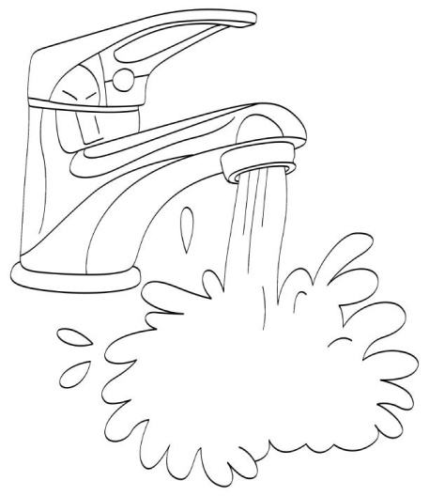 | water | مَاءٌ
 | right | يَمِيْن
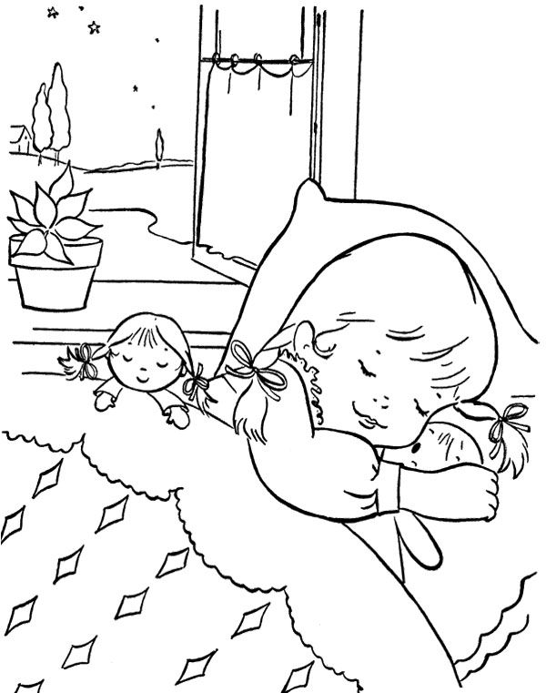 | sleep | نَومٌ

Draw a picture | Copy the word | The word
 |  | مَاءٌ
 |  | يَمِيْن
 |  | نَومٌ

First, write the word three times. Read it aloud each time you write it. Then color the picture.
1.________________ نَومٌ 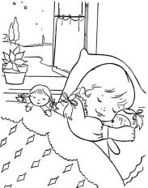
_____________ . 3 _____________ .2
1._________________ يَمِيْن
_____________ . 3 _____________ .2
1._________________ مَاءٌ 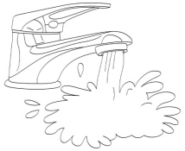
_____________ . 3 _____________ .2

Break down:
___-___-___ نَومٌ
مَاءٌ ___-___-___
___-___-___-___ يَمِيْن

What is the meaning of the following words in Arabic? 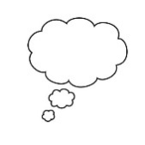
Write the words in Arabic and draw pictures.
- right
_________________________
- water
_______________________
- sleep
_____________________

